Steps for BasicAuthentication in Web API

Create new Web api Project🡺

Right Click on Model Folder and Add new Class with the name of User.cs

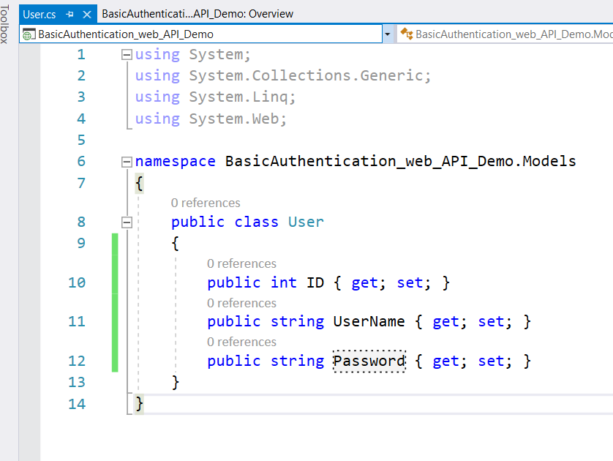

Add another class with the Name of Employee.cs

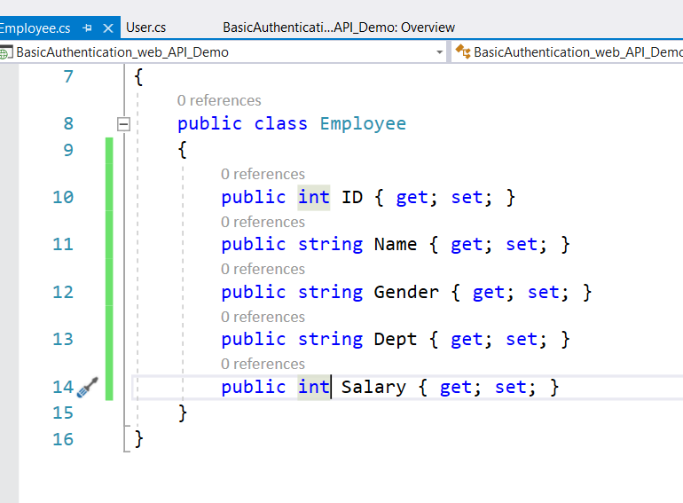

Add new class with the name of UserBL.cs

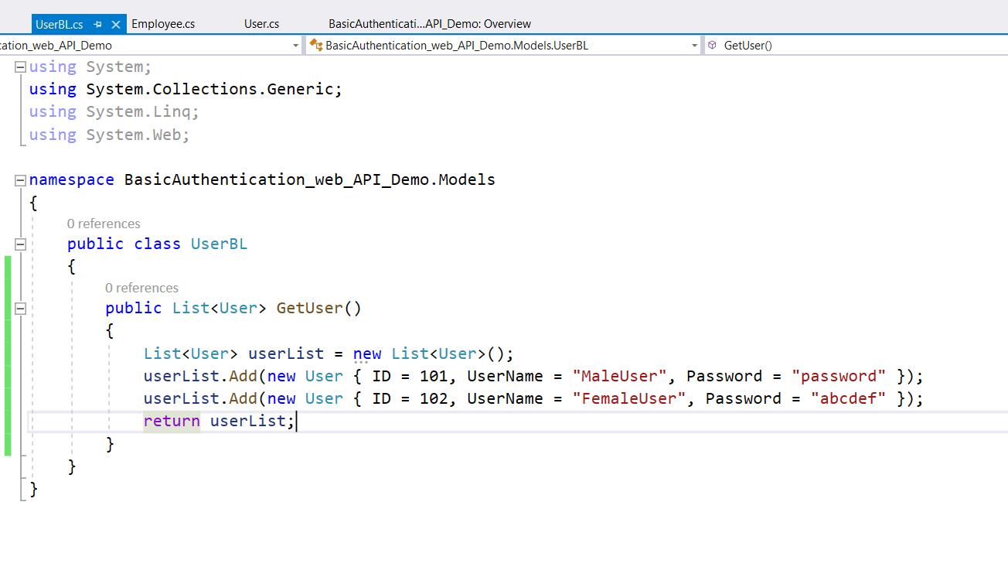

Add new class with the name of EmployeeBL.cs

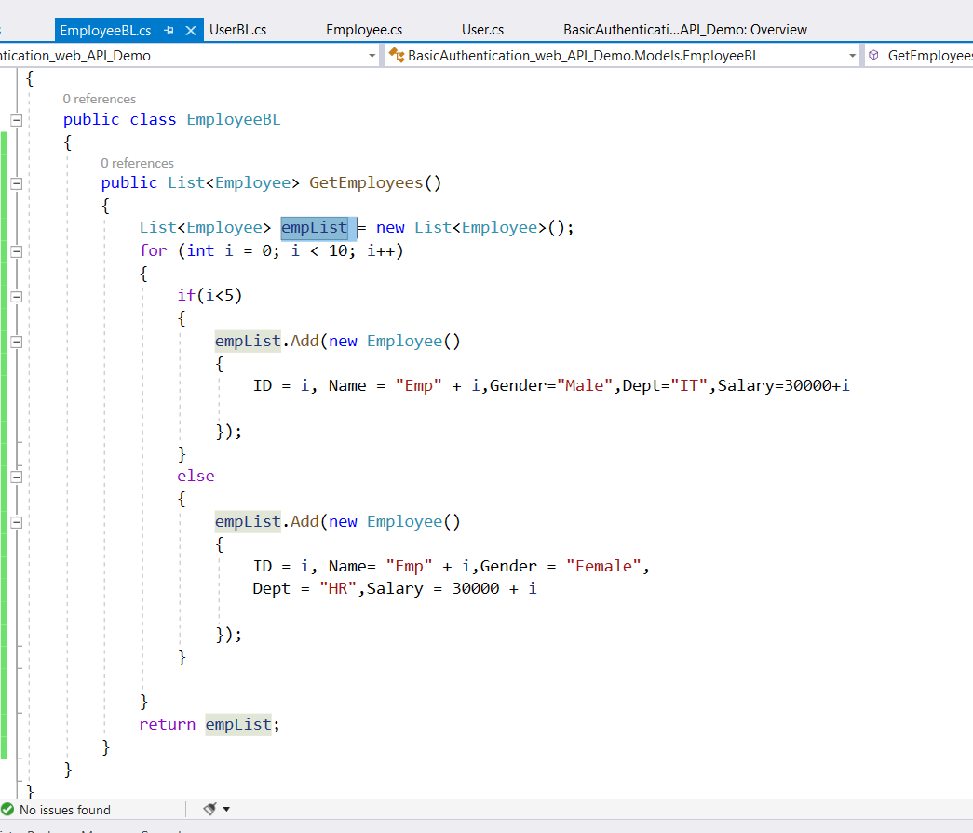

Add another class to check the Username and password is correct or not with the Name of UserValidate.cs

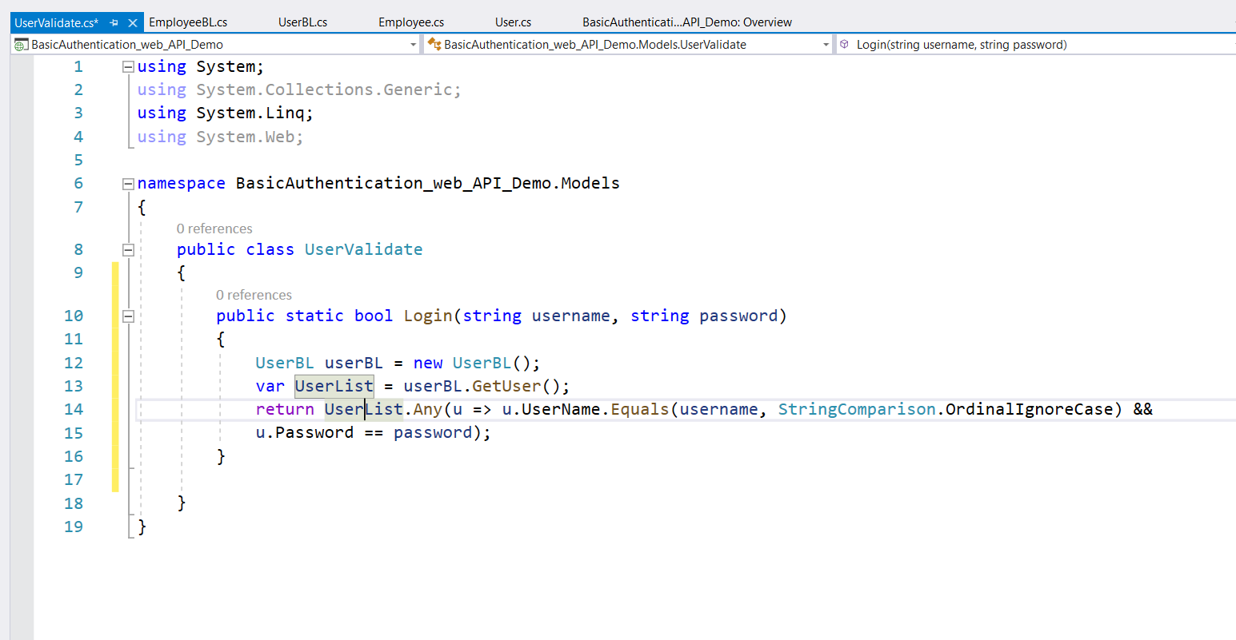

Add Another class to enable AuthorazationFilter with the Name of BasicAuthenticationAttribue.cs

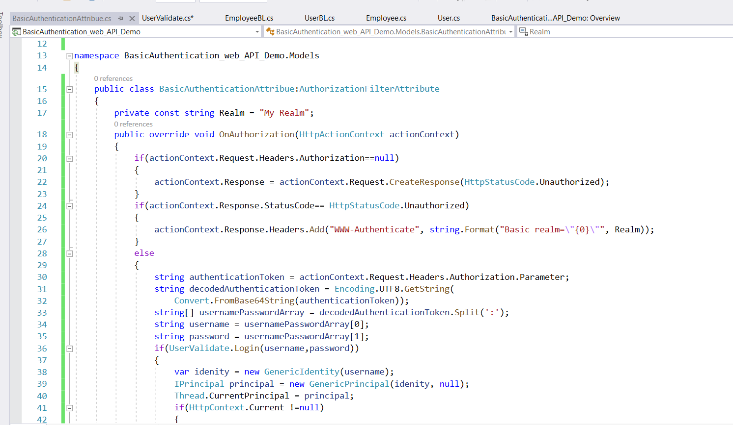

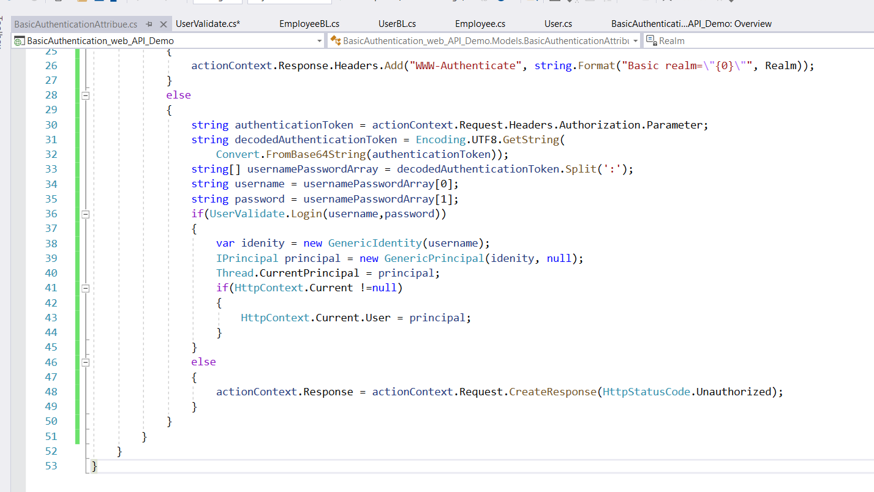

Right click on Cotrollers folder and Add web API Controller Empty. Name it as EmployeeController.

Goto webAPi.config file which is present in Appstart Folder.and Register our Authentication

